BREAST IMPLANT NEWS ORGANIZATIONS
AND SUPPORT GROUPS

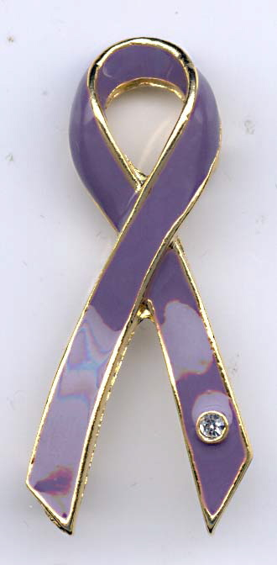

Command Trust Network
Sybil Goldrich – Execuitve Director

11301 West Olympic Boulevard, Suite 332
Los Angeles, CA 90064

Web Site: www.commandtrust.org
E-Mail Address: info@commandtrust.org

National Non-Profit Breast Implant Clearinghouse: Command Trust Network was established in 1988 by Sybil Niden Goldrich and Kathleen Anneken. Their goal was to ensure that women would be provided adequate information to insure informed consent before receiving implants. Today, CTN works to make sure that not only women who were considering breast implants would get the most up-to-date information, but that decision makers in Washington and scientists in related fields would be fully informed, as well.

Coalition of Silicone Survivors

President: Lynda Roth

2739 W. 23rd. St.
Greeley, CO. 80634
Phone: (970) 506-9288

Web Site: www.siliconesurvivors.net
E-Mail Address: coss@privatei.com
National Non-Profit – Silicone Implant Survivor Organization - Founded 1991.
Services Provided - Information, referrals, support

National Silicone Implant Foundation

Martha Murdock, Director / Karen Lawrence, President

Address: 4416 Willow Lane
City: Dallas, TX 75244-7537
State: TX
Zip: 75244-7537
Phone: 972-490-0800 - 817-481-3143
Fax: 972-490-4134

E-Mail Address of Contact Individuals: MAM-NSIF@Prodigy.net & ParfumGigi@aol.com

Type of Organization or Group: NSIF is organized for the purposes of education and research. We are dedicated advocates of the Breast Implant Issue. We do not charge for our services, and operate on donations only.

Background of Organization or Group: A support group for women harmed by; or considering Breast Implant surgery. We have been represented at all FDA Hearings, and the IOM Hearings in Washington DC, since our inception. We have represented the Breast Implant Issue at other Texas and National Women’s' Organizations. We try to always have a presence at any Meetings or Conferences related to our BI Issue. We have provided monetary and transportation assistance to various women so they can continue to help in our advocacy efforts. We are willing to do whatever we can by any means to help anyone who needs truthful information about the Breast Implant Issue. We intend to support any other groups that are; or may become our allies.

Type of Services Provided: Local & Non-Local Group Meetings, National Conferences, Information provided by mail, phone, emails, and BreastImplantNews@Topica.com; an Open Discussion Membership Newsgroup for women and men needing Breast Implant Information; or those wanting to provide information.

Silicone Breast Implant Info
Website: http://www.siliconebreastimplant.homestead.com/
E-Mail Address of Contact Person: kathynye@aol.com
A web site with info about silicone implants and links to other information that may be of interest.
Services Provided: Website that informs about Silicone Breast Implants. Online support group where we try to keep everyone informed when something about implants is in the news or in a medical reviewed paper.

TOXIC DISCOVERY, INC.

Executive Director: Kathy L. Keithley Johnston, R.N.

601 W. Nifong
Bldg. 3B - Suite P.
Columbia, MO. 65203
Phone: (573) 817-2090
Fax: (573) 445-4700

Web Site: www.toxicdiscovery.com
E-Mail Address: info@toxicdiscovery.com

National Non-Profit Consumer Advocacy Organization - Founded: 1994. Registered Nurses on Staff along with Breast Implant Experts & Breast Implant Counselors. Services are free to injured consumers and their families. Donations are accepted. National Publication – “The Toxic News & Views” which is produced weekly via email only. Please e-mail for a free copy. Memberships are available.

Services Provided – Breast Implant Counseling, Educational Material, Research, Emotional Support, Weekly Electronic Newsletter, Memberships, Physician & Attorney Referrals, National Seminars with International Speakers on Medical Device Failures & Chemical Injury. Hours – M-F from 9-5 Central Time.

CHEMICALLY ASSOCIATED NEUROLOGICAL DISORDERS (CANDO)

Contact: Marlene Keeling

P.O. Box 682633
Houston, TX 77268-2633
Phone: (281) 444-0662
Fax: (281) 444-5468

E-Mail Address: keeling.m@att.net

National Non-Profit Organization – Sole purpose is to learn and share the truth about the affects of various types of implants on the human body. This will be accomplished by funding third party, unbiased research using strict research protocol.

